Rotary Club of Kathmandu Mid-Town
Breakfast Chatter



15 December 2006 The Weekly Bulletin of Rotary Club of Kathmandu Mid-Town Bc # 24 of 2006-07

District : 3290 Web: www.rotarymidtown.org.np Club Id : 26776

DECEMBER IS ROTARY FAMILY MONTH
How do we care for fellow Rotarians like family?
~ Remember birthdays and anniversaries
~ Assist when they are sick, lonely, or having difficulties
~ Share their grief during and after a death in the family
~ Celebrate at births, weddings, and graduations

Guest Speaker Jürgen Dahm looking at the certificate of appreciation given by Club President CK Golchha for his talk/presentation at the Club's breakfast meeting on Friday, 8 Dec 2006.

He briefly discussed what he has been doing in Kathmandu for over 10 years for helping poor children for school education and medical care.

He also presented PowerPoint slides of children requiring medical help, identity cards for children, medical records, school performance records, computer education, and so on.
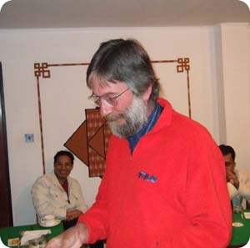

Weekly Meetings and Programs :
Date | Program/Speaker | Program/Topics of Presentation
15 Dec 2006 | Greta Ratliff | Hearing aids for deaf children
22 Dec 2006 | Club assembly | Club assembly
29 Dec 2006 | Dr Banu Sharma | Dental surgery

Friday, 15 December :
Ms Greta Ratliff is a specialist in hearing aids. She has been working with the Welfare Society for Hearing Impaired (WSHI), and what she started out as a project at the deaf school in Naxal to bring hearing aids to deaf children is now going to be expanded to deaf schools all over Nepal. She works with the Starkey Hearing Foundation in the U.S., and they plan to join forces with the Ministry of Education and Sports in nationwide hearing aid distribution. She will be talking about her experience in Nepal – what she has been doing and what she plans to do.

Eye Camp at Hetaura :
The annual eye camp, a joint program of Tilganga Eye Centre, Rotary Club of Kathmandu Mid-Town and Rotary Club of Hetauda, is going to be held at Eye Hospital under construction at Hetaura from 7 to 11 January 2007.

Rotary International President Nominee for 2008-09 :
On 1 December 2006, RI President William B. Boyd declared Dong Kurn Lee to be the official nominee for president of Rotary International for 2008-09. Lee is a Rotary Foundation trustee and a member of the Rotary Club of Seoul Hangang, Seoul, Korea. His formal election will take place at the 2007 Salt Lake City Convention.
Lee is chair of the Bubang Co Ltd and Bubang Techron Co Ltd, manufacturing companies in Seoul and formerly served as a trustee of the Bank of Seoul. In 2005, he was appointed an international goodwill ambassador by the President of Korea.

Lee has also served as honorary consul to the Italian consulate in Korea since 1994 and was awarded the Order of Industrial Merit by the Korean government. He and his wife, Young Ja, have two sons and two daughters.
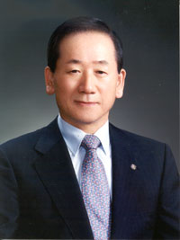

A Rotarian since 1971, Lee has served RI as a director, treasurer, district governor, training leader, regional Rotary Foundation coordinator, and membership task force coordinator in Asia. He began his tenure on the Foundation’s Board of Trustees in 2003-04 and is a recipient of the Foundation’s Citation for Meritorious Service.

On Lighter Side : Click at the figure ⇩


Like our own family, we can count on the family of Rotary to help when help is needed and to share life’s joys and sorrows. Being part of Rotary means being part of the largest extended family in the world.
RI President William B. Boyd

15 December 2006 The Weekly Bulletin of Rotary Club of Kathmandu Mid-Town Bc # 24 of 2006-07

Editor: RR Shrestha, Club Service Director email: rryes@wlink.com.np

